Pick an appropriate software engineering methodology

The waterfall methodology follows a linear sequence of phases, including requirements gathering, system design, implementation, testing, deployment, and maintenance. Each phase has specific goals and activities that must be completed before proceeding to the next phase. This methodology is particularly useful when requirements are well-defined and stable.

Requirements Gathering:

Context Models

In this stage, we identify the external entities interacting with the system. For NoteIgniter, the context model could include entities like the user, the note-taking software itself, and any external systems or devices that interact with it, such as cloud storage services or other applications-in this context model, we have identified two actors: the user and the note.The user interacts with the system by creating, editing, and deleting notes. The note is created, edited, and deleted by the user.
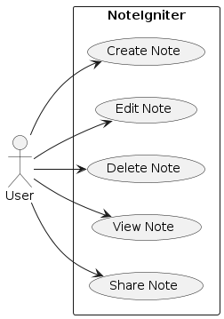

Interaction Model

The interaction model describes how the entities interact with each other. For NoteIgniter, the interaction model may include actions like creating a new note, editing an existing note, deleting a note, searching for notes, and synchronizing notes with external services.

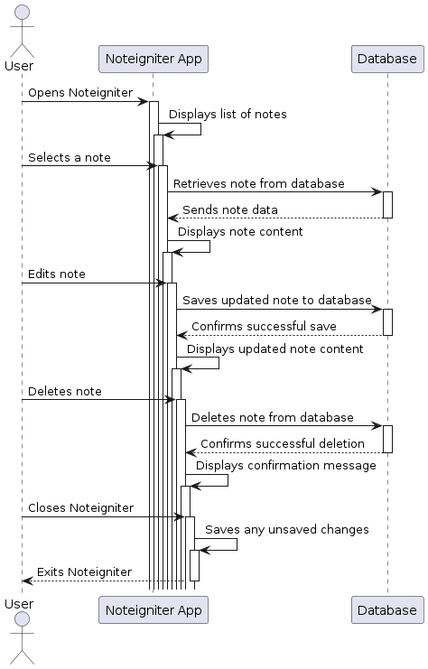

Structural Models

Structural models are used to identify the components of the system and how they are organized

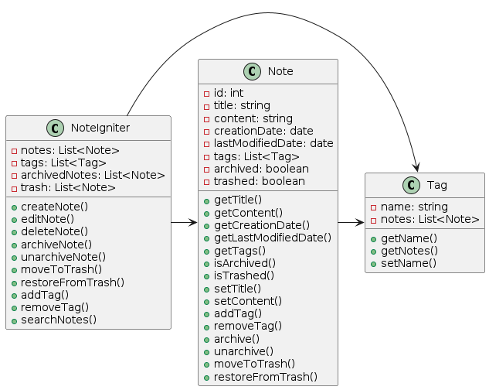

Behavioral Models: The behavioral model describes the dynamic behavior of the system. For NoteIgniter, the behavioral model may include scenarios like a user creating a new note, the system saving the note to the storage, the user editing a note, and the system synchronizing changes with external services.

